**LAPORAN PENGERJAAN UJI KOMPETENSI KEJURUAN**

**SMK MAHARDHIKA BATUJAJAR**

**TAHUN PELAJARAN 2022-2023**

|  |  |
| --- | --- |
| KOMPETENSI KEAHLIAN | :Rekayasa Perangkat Lunak |
| KELAS | :XII RPL 1 |
| NAMA LENGKAP | :M RIFKI JUHARI |
| NISN | :2021.10.355 |
| PAKET SOAL | :P2 |
| JENIS APLIKASI | :Website |
| ALOKASI WAKTU | :24 Jam |

# PENJADWALAN KEGIATAN

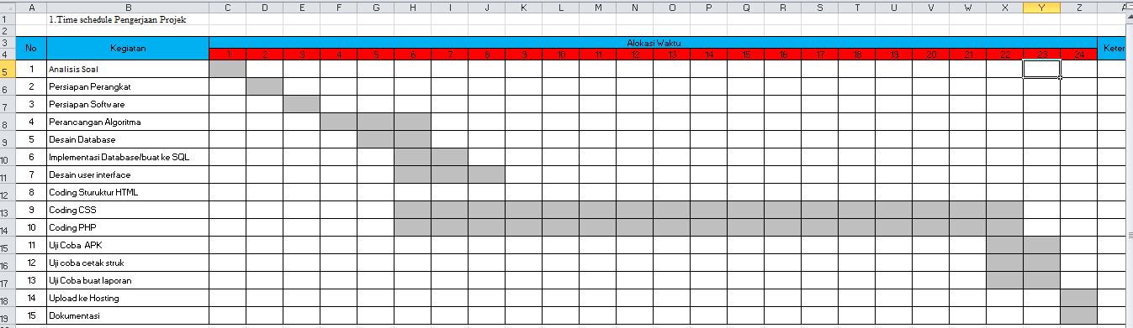

# PERSIAPAN PERANGKAT KERAS

# Laptop

# Ram:4GB

# Windows 10 64 bit

# Laptop lenovo14ast

# Keyboard

# Mouse

# Usb Port

# PERSIAPAN PERANGKAT LUNAK

# XAMPP

# Visual Code Studio

# Browser Chrome

# Astah

# Balsamiq

# PERANCANGAN ALGORITMA APLIKASI

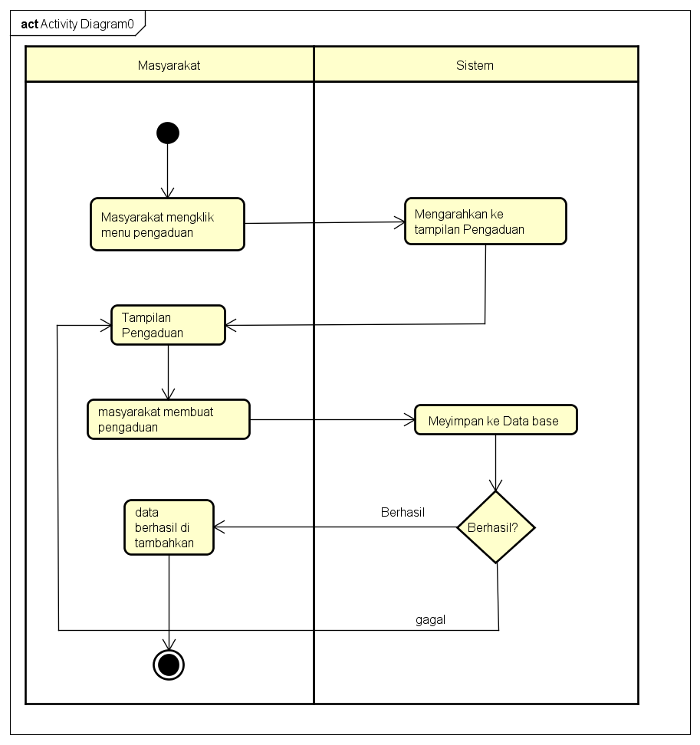

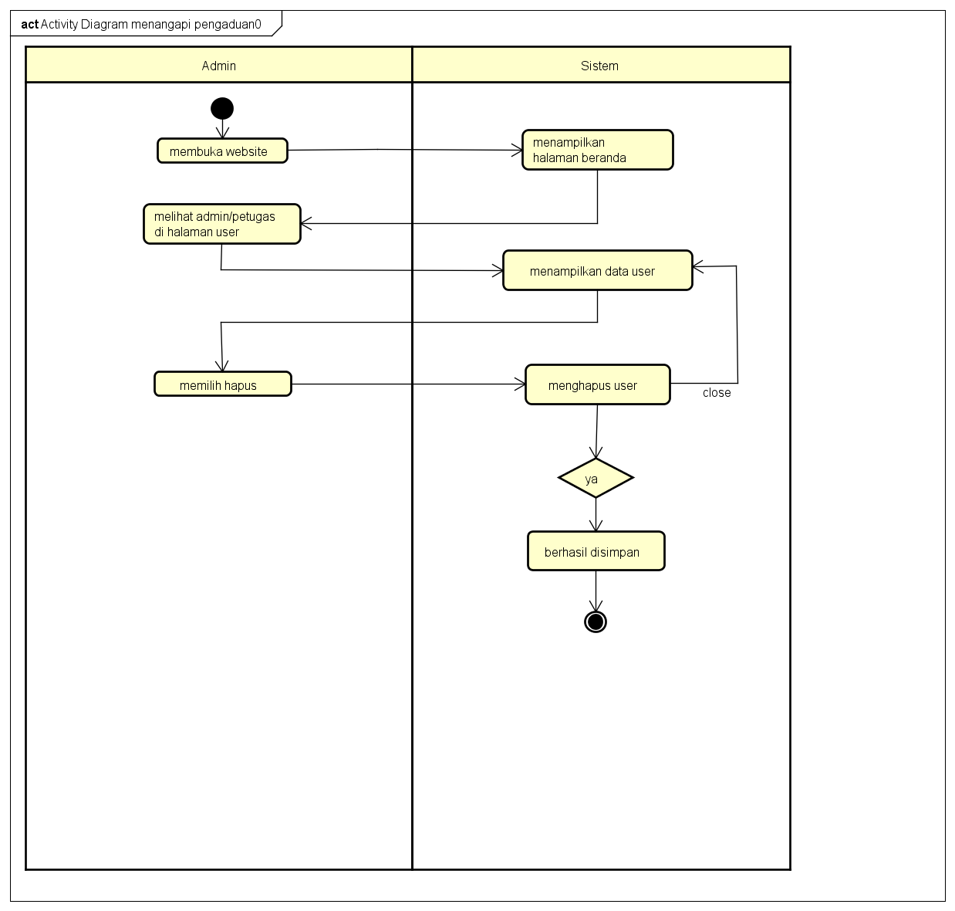

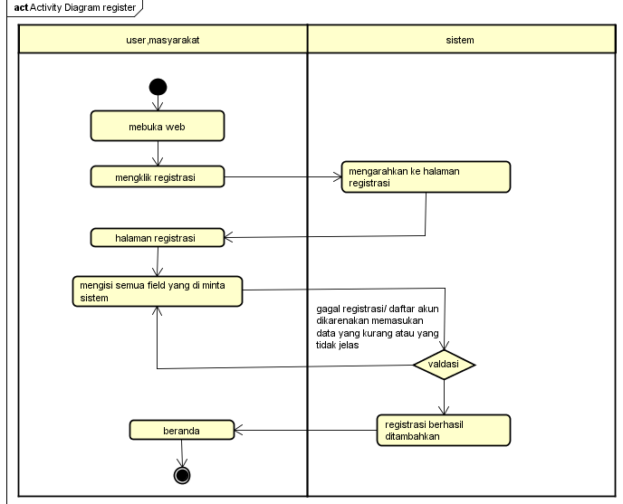

# PERANCANGAN DESAIN BASIS DATA

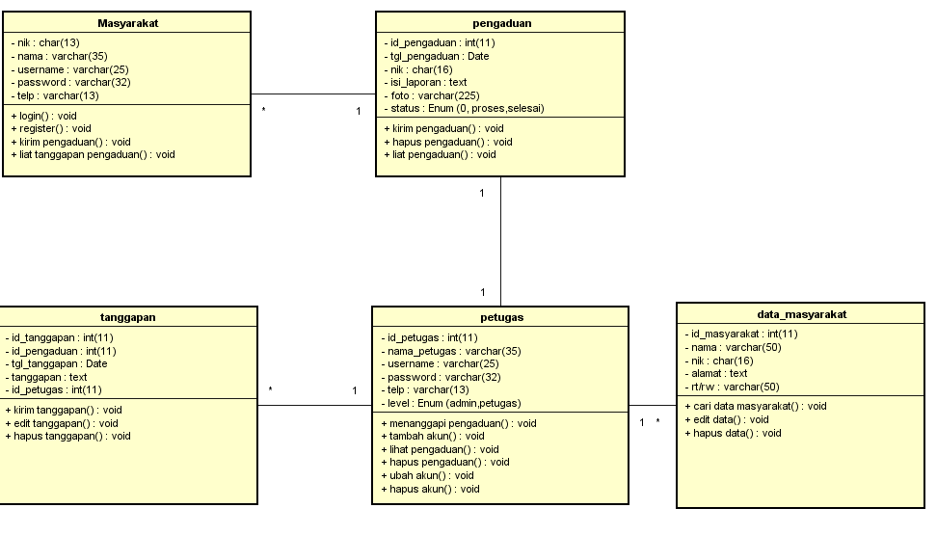

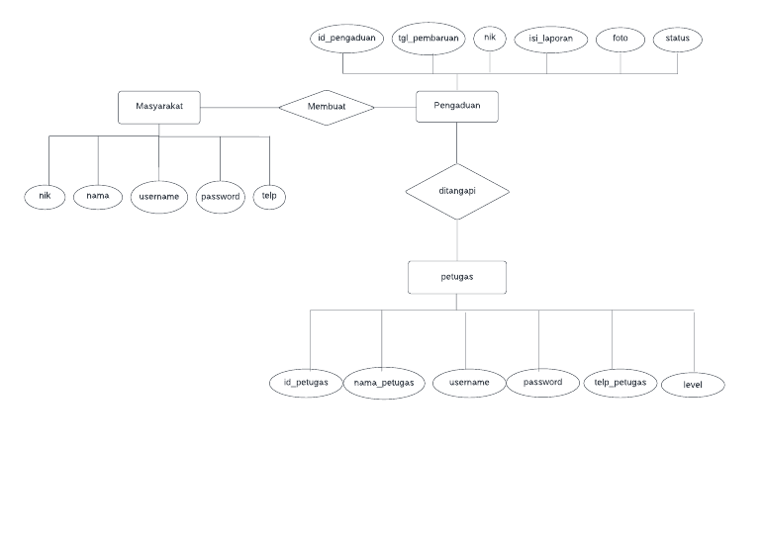

# DUMMY DATA

# Masyarakat

|  |  |  |  |  |  |
| --- | --- | --- | --- | --- | --- |
| NIK | Nama | Username | Rt/rw | Password | Telp |
| 00264374646 | sat | satset | 06/09 | sat | Sate |
| 00578965431 | Pikri | bebees | 06/08 | pikpik | Pikygy |
| 00566666660 | Skyjo | Pasir kalapa | 12/08 | Kijo | Popok |
| 00577000000 | Cassan | Cipatik | 07/07 | Casan | Puandragon |
| 00707070707 | Sadili | Maja | 07/07 | ili | medhok |
| 00264374646 | sat | satset | 06/09 | sat | Sate |

# Petugas

|  |  |  |  |  |  |
| --- | --- | --- | --- | --- | --- |
| **ID Petugas** | **Nama Petugas** | **Username** | **Password** | **Telepon** | **Level** |
| - | Sasa | M4tp | Sako | +66022123658 | Admin |
| - | Sonia | 4kusy | Nia09 | +631200998725 | Petugas |
| - | sopiah | Ik17 | Ik17 | +642399777835 | Petugas |

# Pengaduan

|  |  |  |  |  |  |  |
| --- | --- | --- | --- | --- | --- | --- |
| **ID Pengaduan** | **Tanggal Pengaduan** | **NIK** | **Isi Laporan** |  | **Foto** | **Status** |
| 011124 | 09-08-2020 | 00264374646 | Longsor |  | kk.jpg |  |
| 000358797 | 04-06-2022 | 00578965431 | Kebakaran |  | Sans.png |  |
| 000358798 | 07-17-2023 | 00707070707 | banjir |  | Tiu.jpeg |  |

# PEMBUATAN BASIS DATA (MySQL Code)

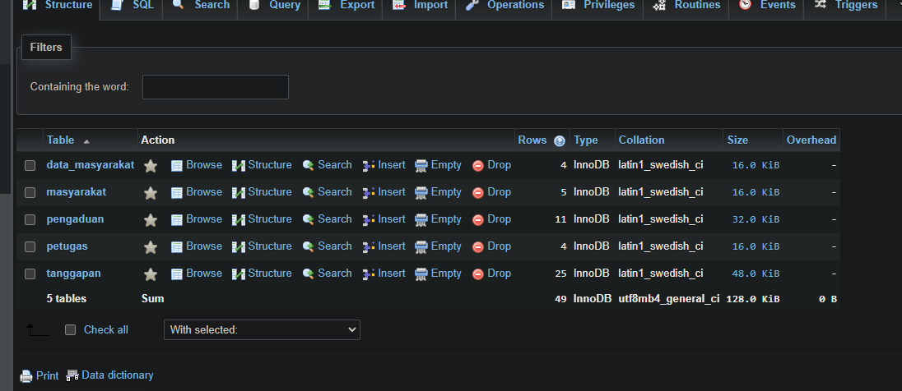

# PERANCANGAN TAMPILAN ANTARMUKA (UI) WEB

* + **Aplikasi pengaduan masyarakat**

1. *Silahkan gambarkan use case diagram aplikasi yang kamu buat*

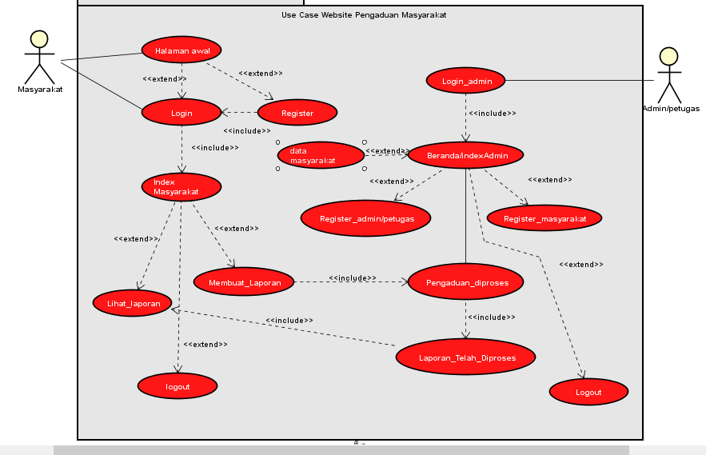

1. Admin dashboard

Tampilan untuk full manage semua data, buatkan sketsa/mockup-nya

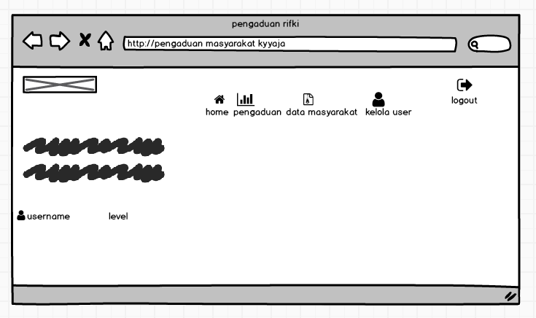

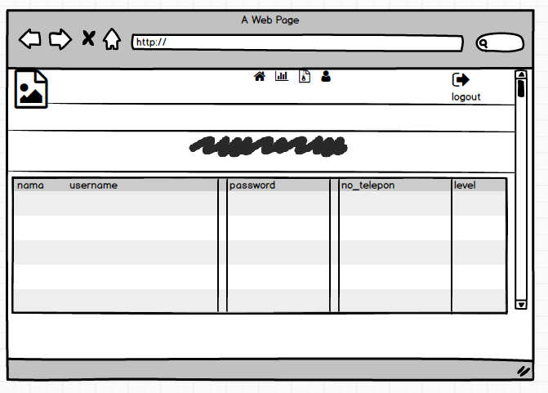

1. Tampilan Petugas

buatkan sketsa/mockup-nya

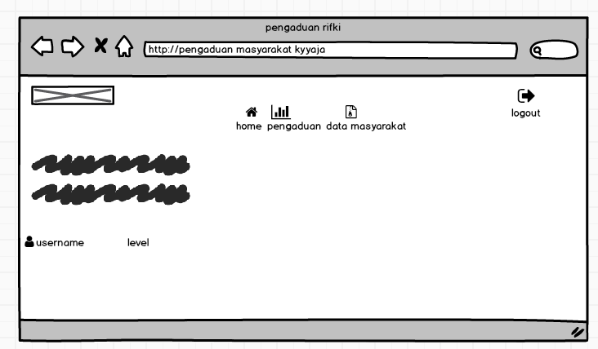

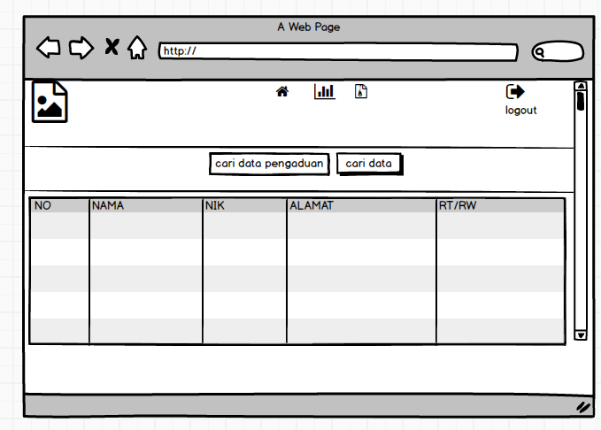

1. Tampilan masyarakat

Dashboard,about,tambah laporan,daftar komentar, tanggapan, buatkan sketsa/mockup-nya

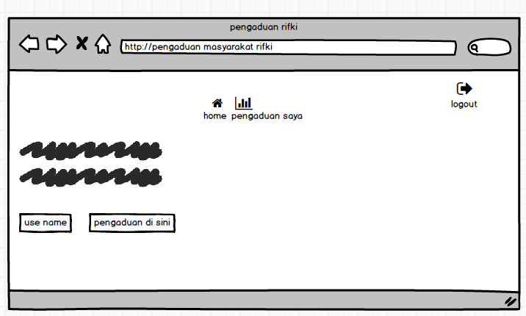

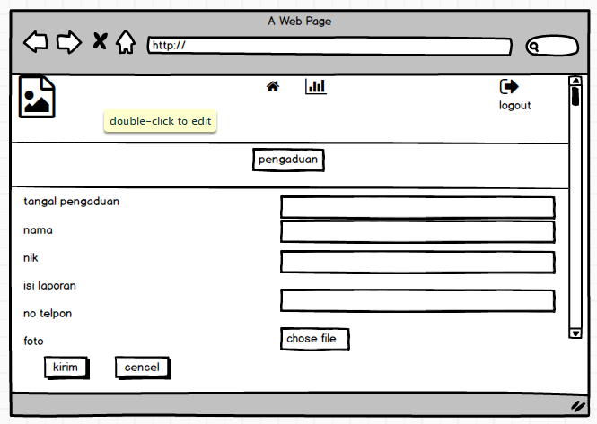

# PEMBUATAN STYLE WEB (CSS)

|  |
| --- |
| @charset "utf-8";  /* CSS Document */  .tabel{  margin-left:50px;  }  .kotak{  padding: px 0px;  }  .titik{  margin-left:60%;  } |

# PEMBUATAN KODE WEB (PHP/JS)

# Index.php (Index Admin)

|  |
| --- |
| <?php  session_start();  include 'koneksi.php';  ?>  <!DOCTYPE html>  <html lang="en">  <head>  <title>Login Masyarakat</title>  <meta charset="UTF-8">  <meta name="viewport" content="width=device-width, initial-scale=1">  <!--===============================================================================================-->  <link rel="shortcut icon" type="image/x-icon" href="img/favicon.png">  <!--===============================================================================================-->  <link rel="stylesheet" type="text/css" href="vendor/bootstrap/css/bootstrap.min.css">  <!--===============================================================================================-->  <link rel="stylesheet" type="text/css" href="fonts/font-awesome-4.7.0/css/font-awesome.min.css">  <!--===============================================================================================-->  <link rel="stylesheet" type="text/css" href="vendor/animate/animate.css">  <!--===============================================================================================-->  <link rel="stylesheet" type="text/css" href="vendor/css-hamburgers/hamburgers.min.css">  <!--===============================================================================================-->  <link rel="stylesheet" type="text/css" href="vendor/animsition/css/animsition.min.css">  <!--===============================================================================================-->  <link rel="stylesheet" type="text/css" href="vendor/select2/select2.min.css">  <!--===============================================================================================-->  <link rel="stylesheet" type="text/css" href="vendor/daterangepicker/daterangepicker.css">  <!--===============================================================================================-->  <link rel="stylesheet" type="text/css" href="css/util.css">  <link rel="stylesheet" type="text/css" href="css/main.css">  <!--===============================================================================================-->  </head>  <body>    <div class="limiter">  <div class="container-login100">  <div class="wrap-login100">  <form method="post" class="login100-form validate-form p-l-55 p-r-55 p-t-178">  <span class="login100-form-title">  SILAHKAN LOGIN  </span>  <div class="wrap-input100 validate-input m-b-16" data-validate="Please enter username">  <input class="input100" type="text" name="user" required="required" placeholder="Username">  <span class="focus-input100"></span>  </div>  <div class="wrap-input100 validate-input" data-validate = "Please enter password">  <input class="input100" type="password" name="pass" required="required" placeholder="Password">  <span class="focus-input100"></span>  </div>  <div class="text-right p-t-13 p-b-23">    </div>  <div class="container-login100-form-btn">  <button name="login" class="login100-form-btn">  <i class="fa fa-sign-in"></i> Login  </button>  <?php  if (isset($_POST ['login'])) {  $user = $_POST['user'];  $pass = $_POST['pass'];  $data_user = mysqli_query ($conn,"SELECT * FROM masyarakat WHERE username ='$user' AND password ='$pass'");  $r = mysqli_fetch_array ($data_user);  $username = $r ['username'];  $password = $r ['password'];  $nama_user = $r ['nama'];  $nik = $r ['nik'];  $tlp = $r ['tlp'];  if ($user == $username && $pass == $password) {  $_SESSION['nama'] = $nama_user;  $_SESSION['nik'] = $nik;  $_SESSION['tlp'] = $tlp;  echo "<div class='alert alert-success'>Login Sukses</div>";  echo "<meta http-equiv='refresh' content='1;url=masarakat_admin.php'>";  } else {  echo "<div class='alert alert-danger'>Login Gagal</div>";  echo "<meta http-equiv='refresh' content='1;url=index.php'>";  }  }  ?>  </div>  <br/>  <center>Belum Punya Acount? Registrasi <a href="../registrasi.php" class="txt3">disini</a></center>  <br>  <div>  <center><a href="../index.php" class="txt3">  Kembali  </a></center>  </div>    </form>  </div>  </div>  </div>      <!--===============================================================================================-->  <script src="vendor/jquery/jquery-3.2.1.min.js"></script>  <!--===============================================================================================-->  <script src="vendor/animsition/js/animsition.min.js"></script>  <!--===============================================================================================-->  <script src="vendor/bootstrap/js/popper.js"></script>  <script src="vendor/bootstrap/js/bootstrap.min.js"></script>  <!--===============================================================================================-->  <script src="vendor/select2/select2.min.js"></script>  <!--===============================================================================================-->  <script src="vendor/daterangepicker/moment.min.js"></script>  <script src="vendor/daterangepicker/daterangepicker.js"></script>  <!--===============================================================================================-->  <script src="vendor/countdowntime/countdowntime.js"></script>  <!--===============================================================================================-->  <script src="js/main.js"></script>  </body> </html> |

# Koneksi.php (koneksi)

|  |
| --- |
| <?php  $conn = mysqli_connect ('localhost','root','','rifkiaja');  ?> |

# UJI COBA

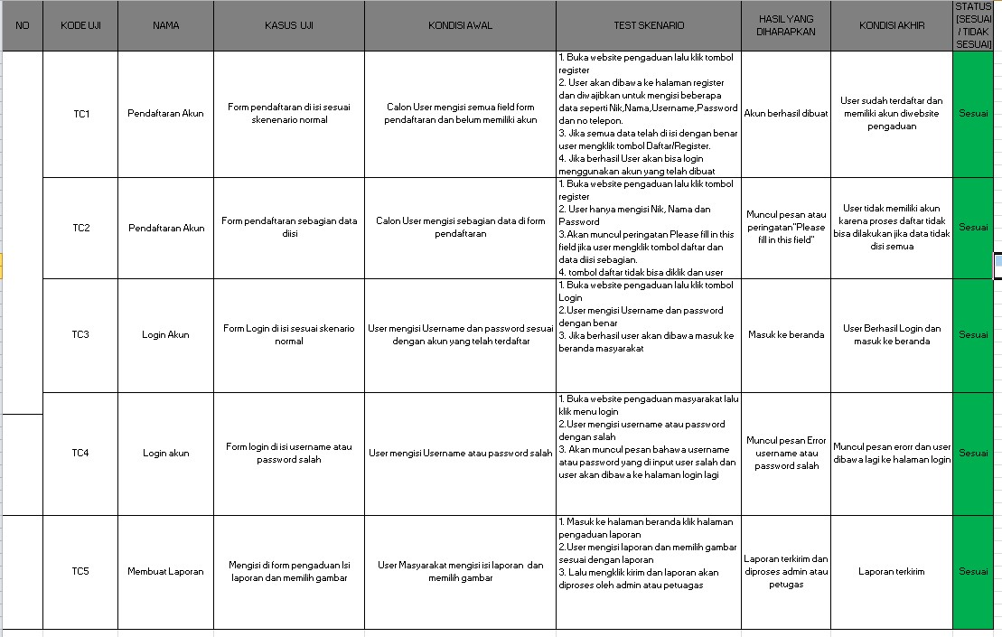

# REVISI

|  |
| --- |
|  |

# PENENTUAN DOMAIN DAN HOSTING

# UPLOAD WEB KE HOSTING

# UPLOAD WEB KE GITHUB

# PEMBUATAN USER GUIDE